authenticated client SMTP submission

* Check Mail Flow / Transportconfig

Get-TransportConfig | Format-List SmtpClientAuthenticationDisabled

Set-TransportConfig -SmtpClientAuthenticationDisabled $false

<https://docs.microsoft.com/en-us/exchange/clients-and-mobile-in-exchange-online/authenticated-client-smtp-submission>

* Check authenticated client SMTP submission status / mail user / Cas-Mailbox

Set-**CASMailbox** -Identity **user@domain.com** -SmtpClientAuthentication**Disabled $false**

* Make sure basic Auth below is enabled  
    
  get-authenticationpolicy | fl identity,allowbasicauth*  
  get-authenticationpolicy | set-authenticationpolicy -allowbasicauthSMTP $true
* Make sure MFA is disabled
* + license + Password (no shared mailbox)
* + legit sender in tenant + From Address + credentials correct

<https://techcommunity.microsoft.com/t5/exchange-team-blog/basic-authentication-and-exchange-online-july-update/ba-p/1530163>

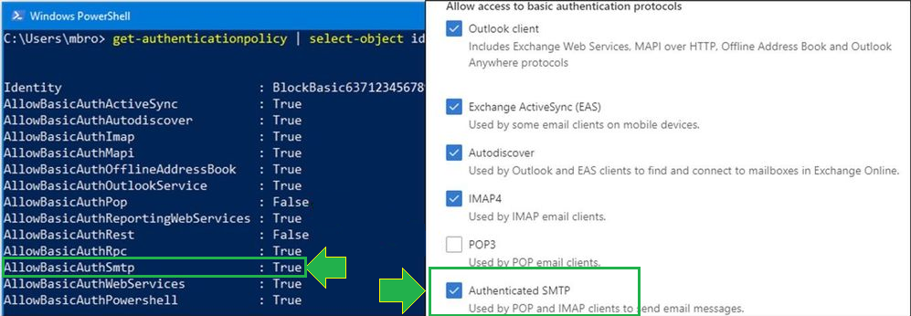

* Enable Basic Auth for SMTP

get-authenticationpolicy | fl identity,allowbasicauth*

get-authenticationpolicy | set-authenticationpolicy -allowbasicauthSMTP $true

<https://techcommunity.microsoft.com/t5/exchange-team-blog/basic-authentication-and-exchange-online-july-update/ba-p/1530163>  
  
------------------------------------------------------------------------------------------------------------------------------------------  
  
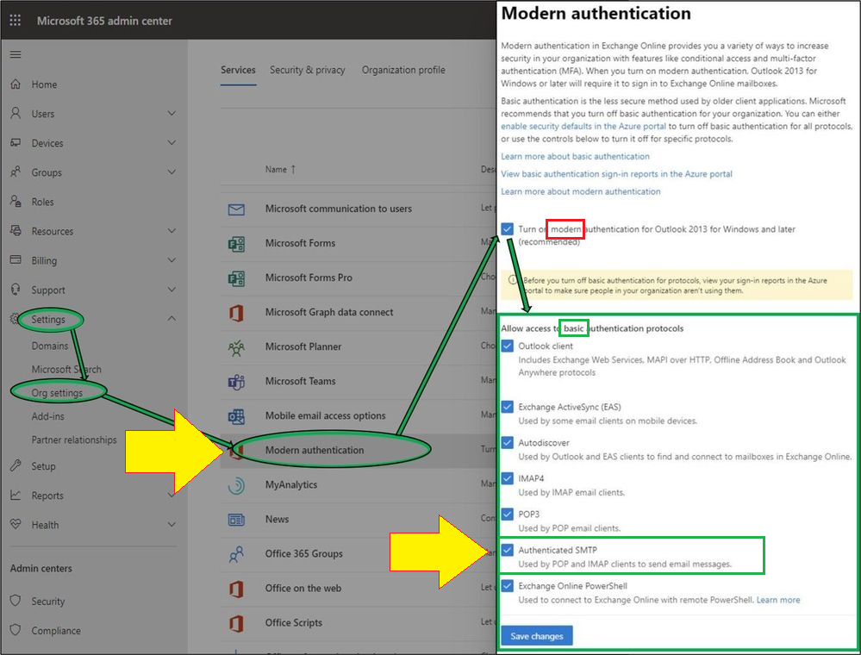

1. test

Send-MailMessage -SmtpServer 'smtp.office365.com' -From ‘sender@domain.com' -To 'someemail@domain.com' -Subject 'this is a subject' -Body 'this is the body' -UseSsl -Port 587 -Credential $credential -Verbose

1. test 2  
     
   $Cred = Get-Credential

$sendMailParams = @{

From = ‘sender@domain.com' ## Must be own tenant

To = 'someemail@domain.com'

Subject = 'some subject'

Body = 'some body'

SMTPServer = ‘**smtp.office365.com’**

SMTPPort = **587**

UseSsl = **$true**

Credential = **$Cred**

}  
  
Send-MailMessage @sendMailParams

3.) test 3  
<https://www.undocumented-features.com/2018/05/22/send-authenticated-smtp-with-powershell/>